

P.E.S. COLLEGE OF ENGINEERING, MANDYA - 571 401
(An Autonomous Institution Affiliated to VTU, Belagavi)

DEPARTMENT OF INFORMATION SCIENCE & ENGINEERING

CERTIFICATE

This is to certify that Hemashree S S bearing USN 4PS21IS021 have successfully completed the Internship work (P21INT802) entitled “Dynamic Frontend Development for a Smart Contract Audit Platform” carried out at 0xteamSpace in partial fulfilment for the award of the degree of Bachelor of Engineering in Information Science and Engineering, P.E.S. College of Engineering (An Autonomous Institution Affiliated to VTU, Belagavi) during the academic year 2024 - 2025.It is certified that all corrections indicated in the internal assessment have been incorporated in the report deposited in the library. The Internship has been approved as it satisfies the academic requirements in respect of Internship work prescribed for the degree of Bachelor of Engineering.

-

------------------------------ | -------------------------------
Signature of Mentor | Signature of the HOD
M R Suresh | Dr. Minavathi
Associate Professor | Professor & Head
Dept. of IS&E | Dept. of IS&E
PESCE, Mandya​ | PESCE, Mandya

Details of Internship Viva Voce Examination held
Sl.  No. | Examiners |  | Date
Sl.  No. | Name | Signature | Date
1.
2.

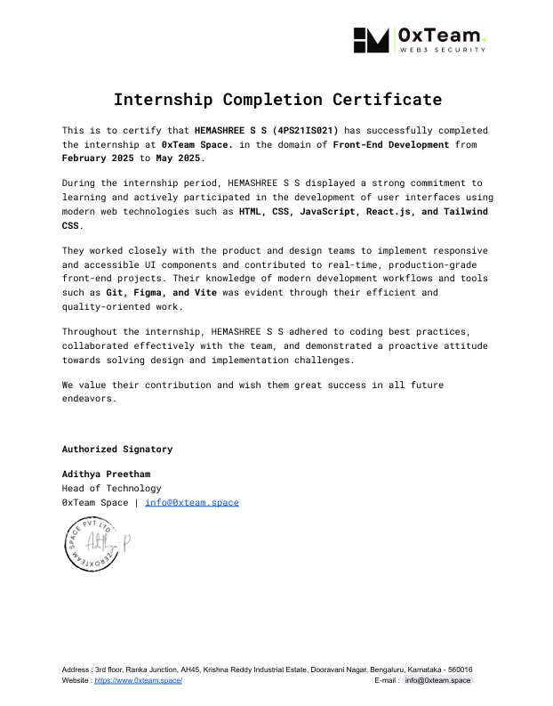

DECLARATION

I, HEMASHREE S S (4PS21IS021) student of 8th semester B.E, Department of Information Science and Engineering, PES College of Engineering Mandya declare that the internship work entitled “Dynamic Frontend Development for a Smart Contract Audit Platform” has been duly carried out and the report for the same is submitted as a part of Internship work (P21INT802) in partial fulfilment for the award of the BACHELOR OF ENGINEERING degree in Department of Information Science and Engineering by the Visvesvaraya Technological University, Belgaum during the course of 4 years (2021-2022 to 2024-2025).

Place: Mandya​ HEMASHREE S S

Date: 15-05-2025 4PS21IS021

ACKNOWLEDGEMENT

The satisfaction that accompanies the successful completion of any task would be incomplete without the mention of the people who made it possible and under whose constant guidance and encouragement the task was completed.

We are grateful to PES College of Engineering, Mandya, for providing us with the opportunity to enhance our knowledge. We take this pleasure in thanking our beloved Principal, Dr. N. L. Murali Krishna, for being a constant source of inspiration and encouragement.

I would like to express my sincere gratitude to Dr. Minavathi, Professor and Head, Department of IS&E, for his encouragement and support throughout the Internship.

I express the deepest sense of gratitude to my mentor, M R Suresh , Associate Professor, Department of IS&E, for the invaluable guidance extended at every stage and in every possible way.

Finally, I am very much thankful to all the faculty members of the Department of IS&E, friends, my parents and everyone who helped me throughout during completion of activity for their constant encouragement, support and help.

HEMASHREE S S

​ 4PS21IS021

ABSTRACT

In today’s digital-first world, front-end development plays a vital role in shaping user experience and driving engagement across web platforms. As part of my internship at 0xteam.space, I had the opportunity to work on real-world web development projects focused on creating responsive, interactive, and user-friendly interfaces. This internship allowed me to apply theoretical knowledge in a professional setting, using technologies such as HTML, CSS, JavaScript, and React.js. I actively participated in the development lifecycle, including UI design implementation, API integration, debugging, and performance optimization. By collaborating with experienced developers and following agile practices, I gained insights into modern web development workflows, version control using Git, and responsive design principles.
Additionally, I learned how to build reusable components, manage state effectively, and follow best practices for clean, maintainable code. Exposure to project planning and sprint reviews improved my time management and teamwork skills. I also gained practical experience in resolving bugs, handling cross-browser compatibility, and optimizing user interfaces. The hands-on nature of the internship helped solidify my understanding of the development process from start to finish. This experience not only strengthened my technical foundation but also boosted my confidence in working on professional-grade projects.

INTERNSHIP WEEKLY PROGRESS PREPORT

Week | Topic Completed
1st Week | Orientation and understanding project requirements and development workflow.
2nd Week | Learned and applied HTML and CSS for building basic webpage layouts.
3rd Week | Practiced JavaScript basics and DOM manipulation for interactive features.
4th Week | Started working with React.js: created components and learned JSX syntax.
5th Week | Used React state and hooks to manage dynamic content and user input.
6th Week | Implemented navigation using React Router for multi-page structure.
7th Week | Integrated Forms for user submissions and linked responses to Google Sheets.
8th Week | Designed dynamic data flow between frontend and Google Sheets using app script logic.
9th Week | Used Framer Motion for adding interactive UI animations and transitions.
10th Week
  Enhanced page layouts with CSS Grid and Flexbox for better responsiveness.
11th Week | Built reusable UI components (buttons, inputs, form layout) using React.
12th Week | Implemented dropdowns, modals, and conditional rendering for better user control.

13th Week
  Integrated icons and external libraries to enhance user experience.
14th Week | Prepared final UI screens, fixed layout alignments, and completed frontend logic.
15th Week | Finalized and deployed the frontend on a hosting platform and created project documentation.

TABLE OF CONTENTS

SI.NO | TITLES | PAGE.NO
1 | INTRODUCTION | 1
2 | LITERATURE SURVEY | 2
3 | SOFTWARE REQUIREMENTS | 4
4 | SYSTEM DESIGN AND IMPLEMENTATION | 6
5 | TASK PERFORMED | 8
6 | SNAPSHOTS | 9
7 | CONCLUSION | 12
8 | BIBLIOGRAPHY | 13

CHAPTER 1
INTRODUCTION

In the current digital age, front-end development plays a crucial role in shaping how users interact with websites and web applications. As businesses and organizations increasingly rely on their online presence to communicate, sell, and provide services, the need for highly responsive, intuitive, and aesthetically pleasing interfaces has grown significantly. A well-structured front-end not only improves user experience but also boosts engagement, accessibility, and conversion rates. Front-end development involves translating UI/UX designs into code and ensuring that the visual aspects of a website are interactive, functional, and optimized across various devices and screen sizes.

During my academic internship, I had the opportunity to work as a Front-End Developer at 0xteam.space, a technology-driven company specializing in Web3 solutions and blockchain-based products. The internship provided me with a platform to apply my theoretical knowledge in a practical, real-world setting and to understand how professional front-end projects are executed from planning to deployment. It allowed me to experience the complete lifecycle of web development, including requirement gathering, UI design interpretation, coding, testing, and deployment support. My primary responsibility during the internship was to contribute to the improvement and maintenance of the company’s official website — https://www.0xteam.space. The goal was to enhance the website’s visual design, responsiveness, and functionality while ensuring a seamless user experience. This involved working with modern web technologies such as HTML5, CSS3, JavaScript, and React.js, as well as tools like Git, GitHub, VS Code, and browser development tools for debugging and performance optimization.

This internship not only enhanced my technical competencies but also taught me professional skills such as communication, teamwork, time management, and attention to detail. Working in a fast-paced, real-world environment helped me understand the challenges and expectations of the industry and encouraged me to continually improve my skills. In summary, the internship at 0xteam.space was a vital milestone in my learning journey. It provided practical exposure to front-end development, equipped me with essential tools and techniques used in the industry, and gave me the confidence to take on more complex web development tasks in the future.

CHAPTER 2
LITERATURE SURVEY

Integration with Sheets for Real-Time Data Handling
This research discusses the integration of Google Forms with Google Sheets, which allows businesses to collect data through forms and automatically store submissions in a spreadsheet for easy management and analysis. It is a lightweight solution for web applications requiring dynamic data storage, without the need for extensive backend setup. The use of Google Forms as a dynamic form-handling tool is particularly beneficial for small-scale businesses or services that require real-time data collection without the complexity of building a full backend infrastructure. This integration supports seamless data handling for applications, streamlining data management and improving workflow efficiency.

Performance Optimization: Static vs. Dynamic Websites
This study examines the shift from static websites, which offer limited interaction, to dynamic websites that provide personalized, real-time content based on user interaction. Dynamic websites are built using technologies like JavaScript and AJAX, enabling content to be updated asynchronously without full page reloads. The research highlights that dynamic websites offer a more engaging and interactive user experience by providing real-time data updates, such as form submissions or content personalization. This approach leads to improved user satisfaction, increased engagement, and faster data processing, particularly when handling forms and interactive features.

Enhancing User Experience with Framer Motion Animations
Framer Motion is a powerful animation library for React.js applications, enabling developers to easily create smooth, interactive animations with minimal performance overhead. The research highlights the importance of animations in enhancing user experience (UX) by making interactions more engaging and visually appealing. Animations help guide users through transitions, provide feedback on actions (such as form submissions), and improve the overall flow of a website. The study emphasizes the balance between aesthetics and performance, stating that Framer Motion’s ability to optimize animations without sacrificing speed is a key reason for its adoption in modern web development.

CHAPTER 3
SOFTWARE REQUIREMENTS

Components | Specification
Programming Language | HTML, CSS, JavaScript
Framework | React.js
Operating System | Cross-platform (Windows, macOS, Linux)
Tool | Visual Studio Code (IDE)
Version Control | Git, GitHub

Programming Language:
HTML (HyperText Markup Language): Defines the structure and content of the web pages, such as headings, paragraphs, and links.
CSS (Cascading Style Sheets): Provides styling and layout for the website, including colors, fonts, spacing, and responsiveness.
JavaScript: Adds interactivity to the website by handling user events like clicks, form submissions, and animations.

Framework:
Component-Based: React.js is a JavaScript library that uses components, which allow you to break down the UI into reusable, manageable sections.
Virtual DOM: React uses a virtual DOM to update only the parts of the page that change, improving performance and user experience.
Efficient Rendering: React optimizes UI rendering, ensuring a fast and dynamic experience for users by efficiently managing state and updates.

Operating System:
Cross-platform: The website is designed to work across different operating systems (Windows, macOS, Linux), providing flexibility for users and developers.

Tool:
Code Editor: Visual Studio Code (VS Code) is a lightweight, feature-rich editor for writing, debugging, and editing code.
Extensions Support: It supports extensions for various languages and frameworks, enhancing development with features like auto-completion, linters, and version control.
Integrated Terminal: VS Code includes an integrated terminal, enabling developers to run commands and scripts directly within the editor.

Version Control:
Git: Git is a version control system that tracks code changes, enabling developers to manage different versions and collaborate effectively.
GitHub: GitHub is an online platform for hosting Git repositories, allowing developers to share, collaborate, and maintain their codebase remotely.
Collaboration: Git and GitHub support teamwork by allowing multiple developers to work on different branches and merge changes seamlessly.

CHAPTER 4

SYSTEM DESIGN AND IMPLEMENTATION

System Design – Overview
The system design of the 0xteam.space website was structured to deliver a responsive, interactive, and user-friendly experience using modern web technologies. The frontend was developed using React.js to build a modular, maintainable interface. Key features included animation integration through Framer Motion, real-time form submission with Google Forms, and automatic data storage in Google Sheets. The website follows a component-based architecture where each section (like About, Services, and Contact) is treated as a reusable module. This improves maintainability and reduces redundancy. Navigation was handled through React Router for a seamless user experience. The design also incorporated responsiveness to cater to users across devices and screen sizes. Tools like GitHub and Visual Studio Code were used for version control and development. The overall system design focused on simplicity, performance, and scalability. It supports future extensions such as backend integration or admin dashboards if needed.

Existing System
The earlier version of the 0xteam.space website was static, with limited interactivity and no real-time data handling capabilities. It lacked responsiveness and animation, making the user experience less engaging. Any form submissions were either not functional or required manual methods like email-based contact, which were inefficient. There was no backend integration, and user inputs couldn’t be easily tracked or analyzed. The website did not make use of dynamic frameworks or state management tools. Users had no feedback upon submission, and the performance was subpar due to the lack of optimization techniques. Additionally, the design was basic, not optimized for different screen sizes or accessibility. The site lacked integration with tools like Google Sheets or analytics services. As a result, it failed to meet modern usability standards and required a redesign.

Proposed System
The proposed system involved a complete overhaul of the website into a dynamic, modern frontend using React.js. It introduced features like Framer Motion for smooth animations and transitions, enhancing visual appeal and interactivity. A significant upgrade was the integration of Google Forms directly embedded within the site for audit request submissions. This form automatically links to Google Sheets, eliminating the need for manual data collection. The site was made fully responsive to support all screen sizes and devices. Performance was optimized using lightweight code, lazy loading, and proper component management. The structure followed modular development principles, allowing scalability and ease of future maintenance. Version control was implemented via Git and GitHub, ensuring collaborative development and change tracking. Hosting and deployment could be done through platforms like AWS or Vercel. The proposed system significantly improved user engagement, functionality, and backend data management.

CHAPTER 5
TASK PERFOMED

1. Dynamic Frontend Development with React.js
During my internship, the first and most significant task was transforming the existing static website into a fully dynamic, component-based structure using React.js. I built the frontend using modular components, allowing for better code reuse, easier updates, and a cleaner development workflow. React’s virtual DOM helped ensure faster rendering, and I used React Router for smooth navigation between pages without reloading. This modern approach drastically improved the performance and user interactivity of the website. Through this, I also gained hands-on experience in managing state using React Hooks like useState and useEffect, making the website responsive to real-time user actions and data changes.

2. Implementing Interactive Features and Animations
To improve the visual appeal and user engagement of the site, I integrated Framer Motion, a popular React animation library. I used animations for button hover effects, page transitions, and section reveals to make the interface lively and smooth. These subtle animations guided the user's attention to key areas of the site while enhancing the overall navigation experience. Animations were carefully optimized so as not to hinder performance, especially on mobile devices. Combined with responsive layouts and mobile-friendly breakpoints, the frontend became much more professional and visually polished, offering users a modern browsing experience.

3. Customer-Centric Sections: Reviews, Spotlight & Featured Audits
I designed and developed several new content sections focused on building user trust and showcasing the company's capabilities. The Customer Reviews section features testimonials from clients, helping establish credibility through real feedback. The Featured Security Audits area presents a summary of key projects completed, highlighting the depth and scope of the team's audit expertise. In addition, I created a Spotlight section that draws attention to recently completed or high-impact audits with more detail. These additions not only improved the content structure of the website but also served as proof of the company's success and professionalism in the Web3 space.

4. Products and Services Display
A new Products section was added to the website to clearly outline the services provided by the company. Each product or package, such as audit offerings, security analysis tools, or consulting options, was displayed using interactive cards styled with consistent design patterns. This section helps users quickly understand what is available and choose a service suited to their needs. Clear categorization and brief summaries ensure the content remains concise and digestible. I used CSS Grid and Flexbox to maintain a responsive layout, ensuring that the section is easy to navigate across all screen sizes.

5. Request Audit Form with Google Sheets Integration
One of the most functional additions I implemented was a custom audit request form. Rather than using a traditional backend or third-party service, I created a React form that integrates directly with Google Sheets via Google Apps Script. This allowed the website to collect user submissions and store them in real time on a connected spreadsheet. The process is lightweight, fast, and eliminates the need for a complex backend system. Admins can instantly access and manage audit requests in an organized sheet, which significantly improves lead tracking and workflow efficiency. This integration provided a reliable solution for dynamic data handling without server-side code.

6. Admin Access and Data Handling Workflow
To complement the audit request system, I ensured that all submitted form data was cleanly formatted and immediately accessible to the admin team. Google Sheets served as a centralized dashboard for incoming leads, where the team could filter, sort, and prioritize audit requests. This replaced the older manual method and saved time while reducing the risk of data loss or mismanagement. Additionally, the form included all necessary fields to capture important details like contact info, project type, urgency, and preferred audit timelines. The combination of a dynamic frontend and automated storage helped streamline internal operations and enhance user satisfaction.

CHAPTER 6
SNAPSHOTS

Fig 1: Entry Page
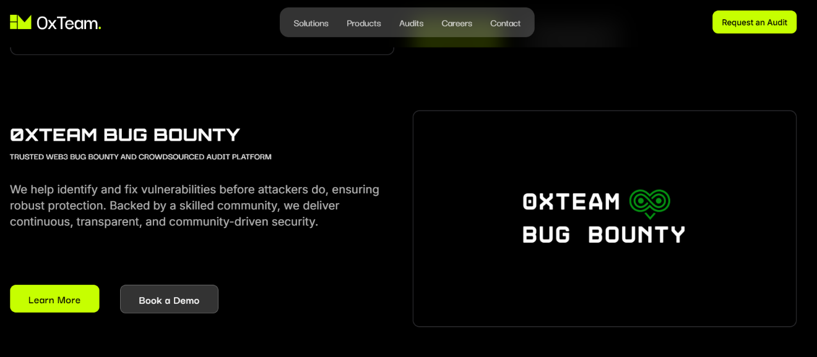
Fig 2: 0xteam Bug Bounty
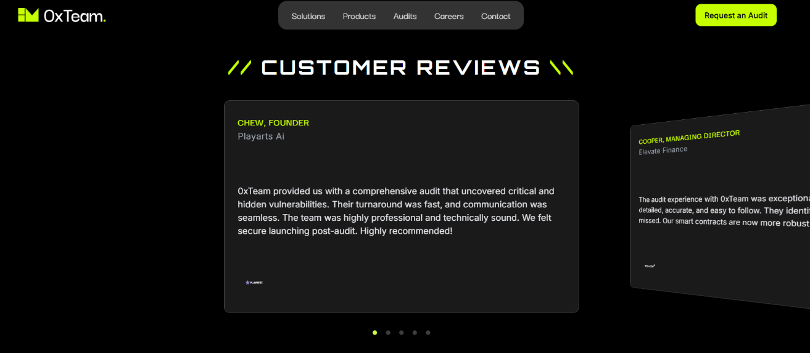
Fig 3: Customer Review Page
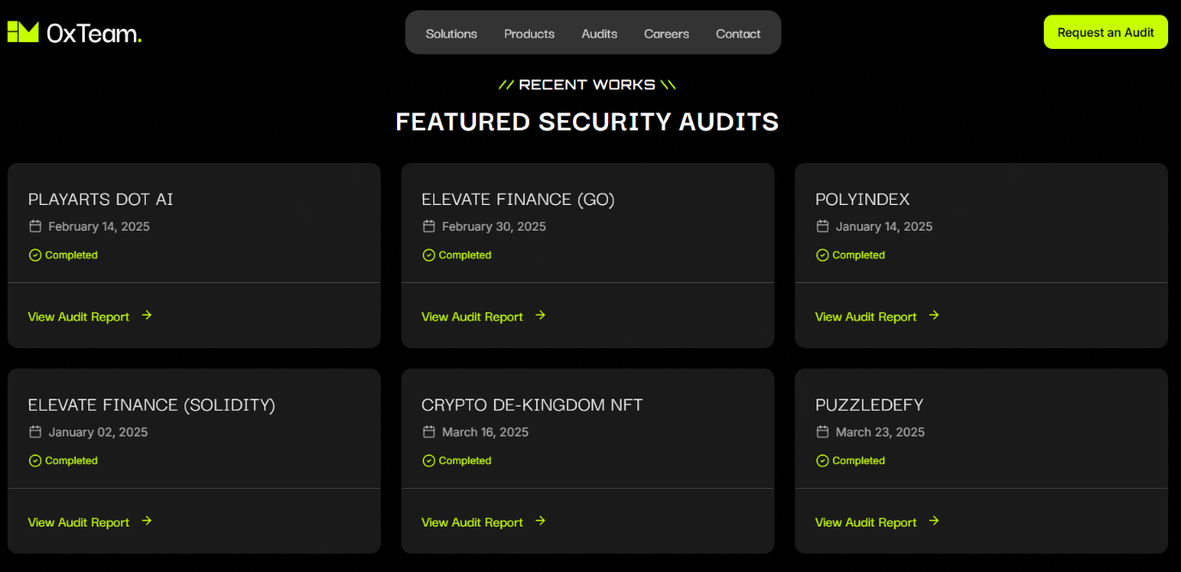
Fig 4: Featured Security Audits Page
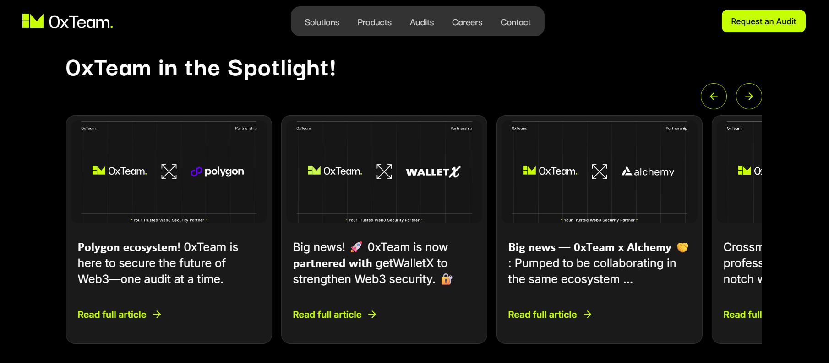
Fig 5: Spotlight of 0xTeam
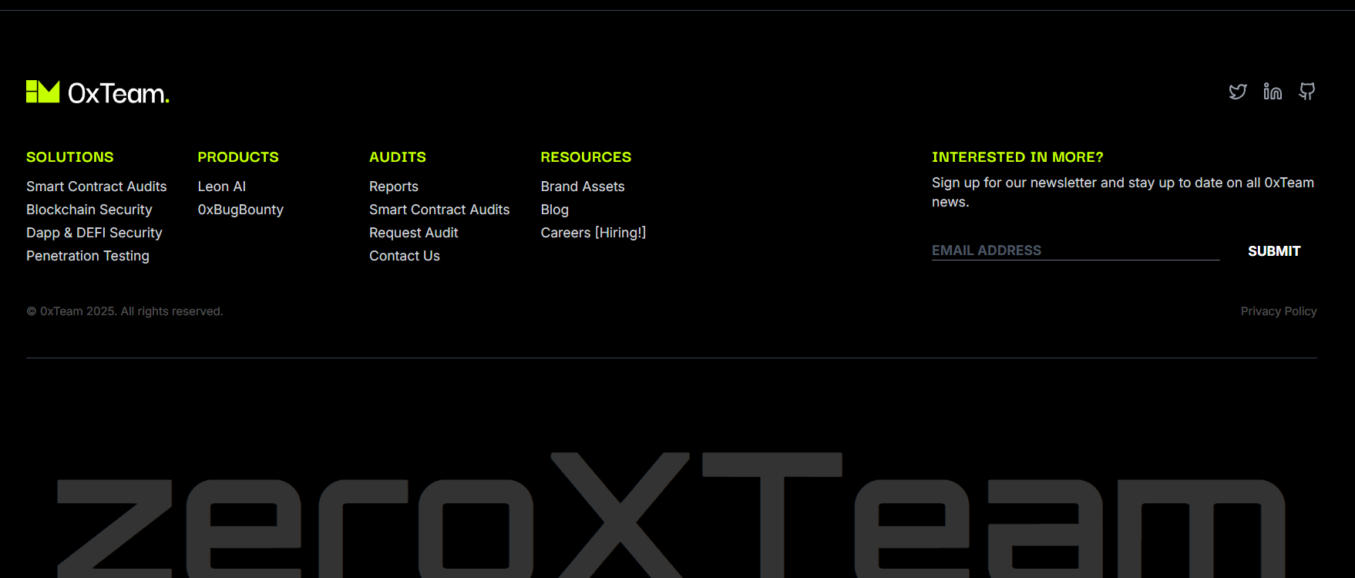
Fig 6: Contact Page Of 0xTeam
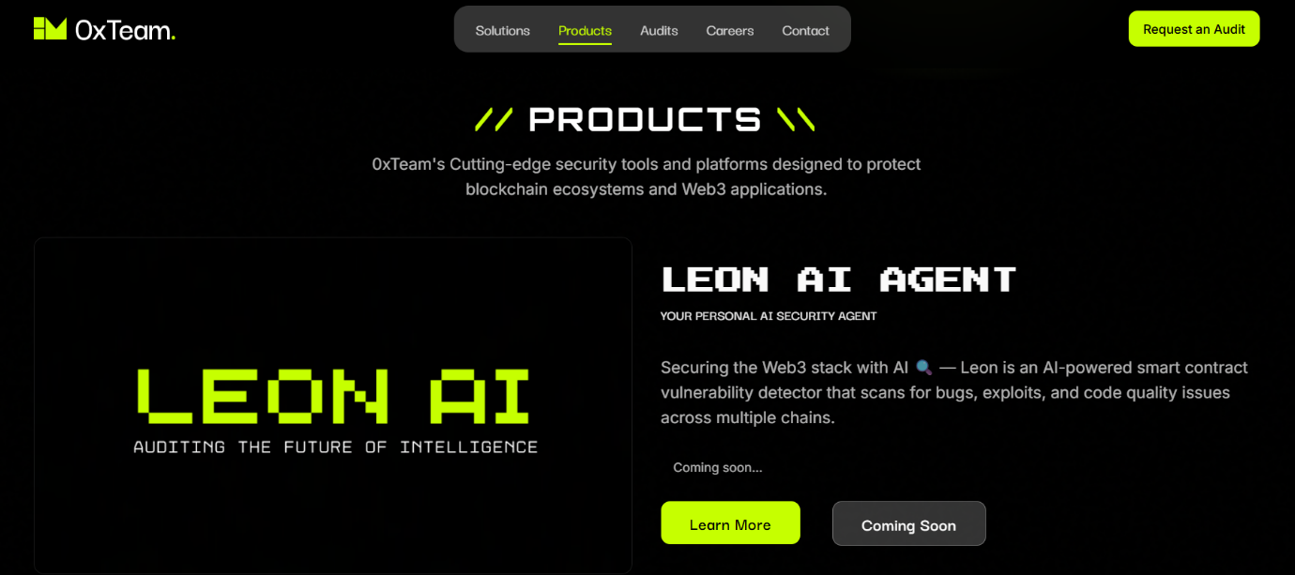
Fig 7: Products Page

Fig 8: Audits Page
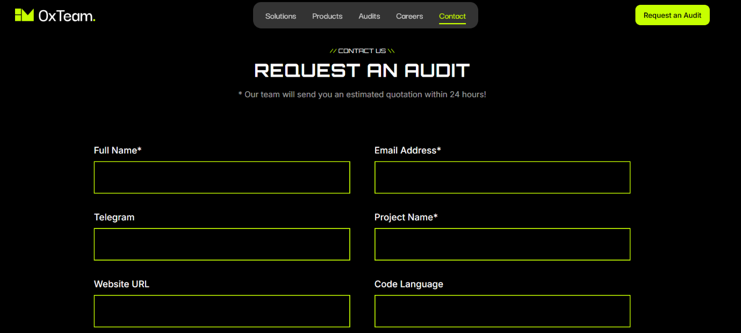
Fig 9: Requesting For Audit Page

CHAPTER 7
CONCLUSION

The internship at 0xteam.space provided an enriching and practical experience that allowed me to explore the dynamic field of front-end development in a real-world environment. During this period, I had the opportunity to work on the official website of the organization, transforming it from a static and slow version into a responsive, interactive, and dynamic platform. Through the integration of modern technologies like React.js, Framer Motion for animations, and Google Forms with Google Sheets for seamless form submissions, I not only enhanced the user experience but also gained practical skills in designing scalable and efficient web interfaces. This hands-on experience strengthened my understanding of modern web technologies and their practical application in delivering impactful solutions.

Furthermore, the internship improved my problem-solving, collaboration, and communication skills as I worked closely with the team to meet specific design and performance goals. I also learned to use tools like GitHub for version control and AWS for deployment, which broadened my exposure to industry-standard practices. This experience has given me a clear vision of how front-end development contributes to the overall success of a web application and prepared me for future roles in the tech industry. I am grateful to 0xteam.space for providing me with this valuable opportunity, which has significantly contributed to both my technical growth and professional confidence.

Additionally, this internship helped me understand the importance of user-centric design and how even small performance optimizations can significantly improve the usability of a website. Learning to debug issues, test across devices, and implement feedback were key aspects of the project that contributed to my learning curve. As a result, I feel better equipped to handle complex front-end tasks and contribute meaningfully to future projects in both academic and professional settings. This experience has laid a strong foundation for my career in web development and motivated me to continue exploring innovative technologies in the front-end ecosystem.

CHAPTER 8

BIBLIOGRAPHY

1.The Evolution of Web Development: From Static Pages to Dynamic Applications and the rise
https://www.researchgate.net/publication/388953886_The_Evolution_of_Web_Development_From_Static_Pages_to_Dynamic_Applications_and_the_Rise_of_Progressive_Web_Apps

2.ResearchGate. (n.d.). The Evolution of Web Development: From Static Pages to Dynamic Applications and the Rise of Progressive Web Apps.
https://www.researchgate.net/publication/388953886_The_Evolution_of_Web_Development_From_Static_Pages_to_Dynamic_Applications_and_the_Rise_of_Progressive_Web_Apps
3 https://www.framer.com/motion/

4. https://en.wikipedia.org/wiki/GitHub

5 https://en.wikipedia.org/wiki/Responsive_web_design

6. https://en.wikipedia.org/wiki/Google_Sheets

